Data Analysis using Hadoop: Module 6, Lesson 4  
Getting Started with Azure IoT Hub Hands-On Lab

## Overview

In this lab, you will create the remote monitoring preconfigured solution with IoT Suite in Azure. And, you will create an IoT Hub.

## Objectives

In this hands-on lab you will learn how to:

* How to provision the remote monitoring preconfigured solution for IoT suite.
* How to use the Azure portal to create an IoT Hub.

## Prerequisites

The following are required to complete this hands-on lab:

* A Microsoft Azure subscription
* A Web browser

Note : The Azure portal is continually improved and changed. The steps in this exercise reflect the user interface of the Microsoft Azure portal at the time of writing, but may not match the latest design of portal.

## Exercises

This hands-on lab includes the following exercises:

* Exercise 1: Provision the remote monitoring preconfigured solution
* Exercise 2: Create an IoT Hub in Azure.

## Exercise 1: Provision the remote monitoring preconfigured solution

The first task you have to perform is to creation of IoT Hub.

1. In a web browser, navigate to azureiotsuite.com. Sign into the portal using your subscription, and click + to create a IoT solution.

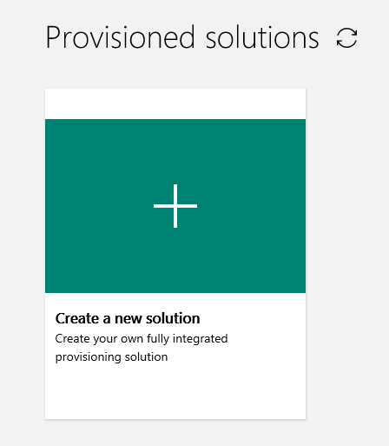

1. Select on the Remote monitoring tile.

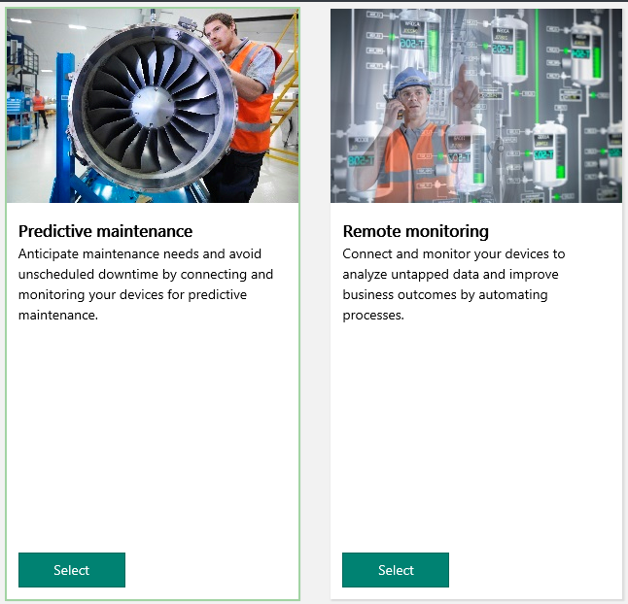

1. Enter a solution name for your remote monitoring preconfigured solution. Select the Regine and subscription you will use to provision the solution. And, Click create solution.
2. This takes several minutes to create. If you want to show detailed provisioning status, click the detail button.

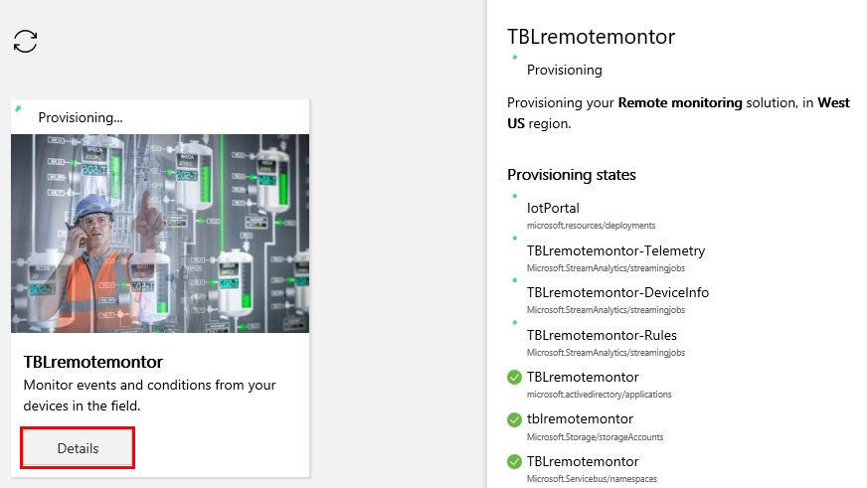

1. When the Remote monitoring solution has been created successfully, the status changes to ready. Click on the tile and you’ll see the details of your solution in the right-hand pane.
2. Click Launch to open your remote monitoring solution portal in a new tab.

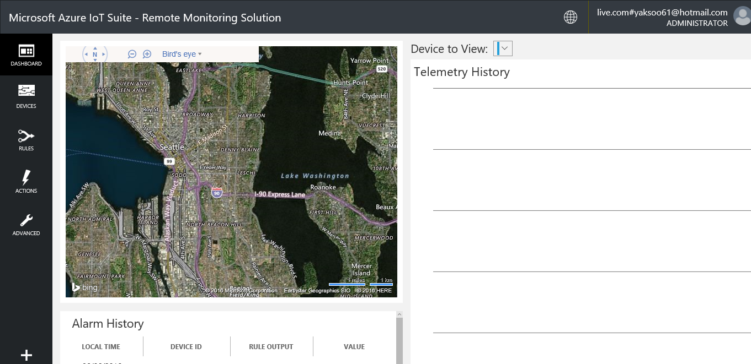

1. Show the device list for this solution using click devices in the left menu.

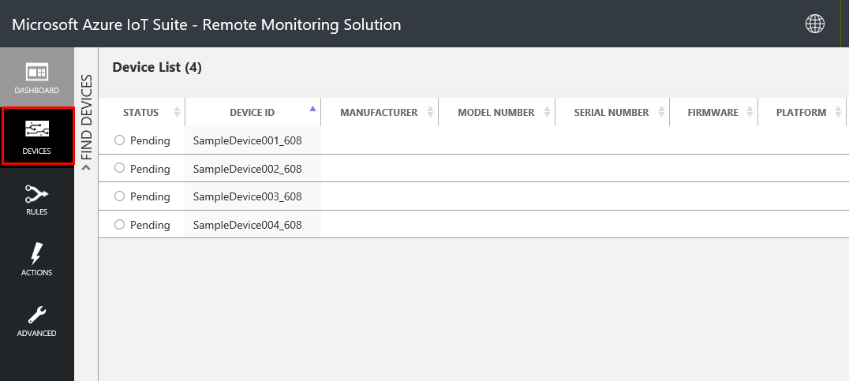

1. Click on the device in the list to view the detail information.

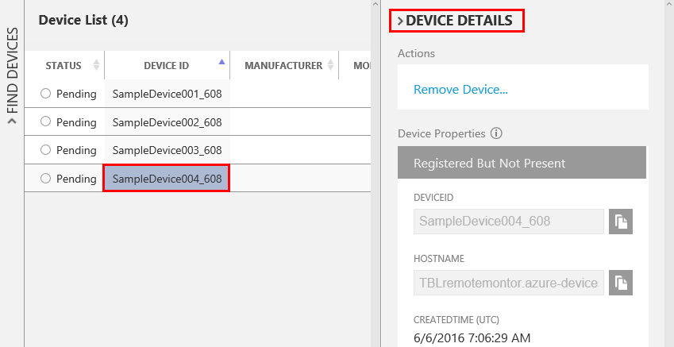

1. Add a new simulated device in you solution. Click + Add A deive in the left menu.

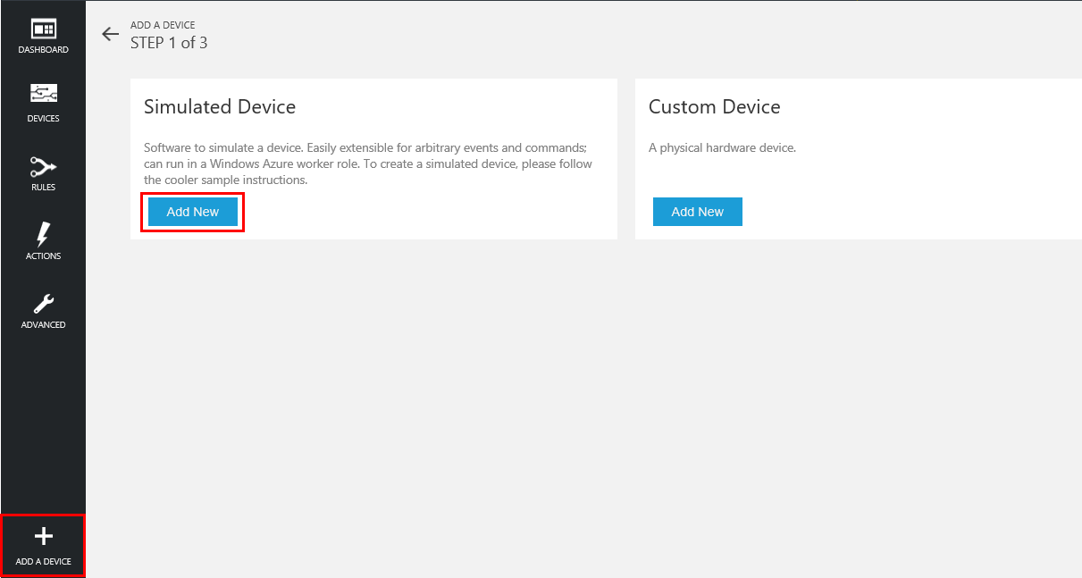

1. In addition to creating a new simulated device, you can also add a physical device if you choose to create a Custom Device. In this lab, we create simulated device. Select “Let me define my own Device ID”, and enter a unique ID name.

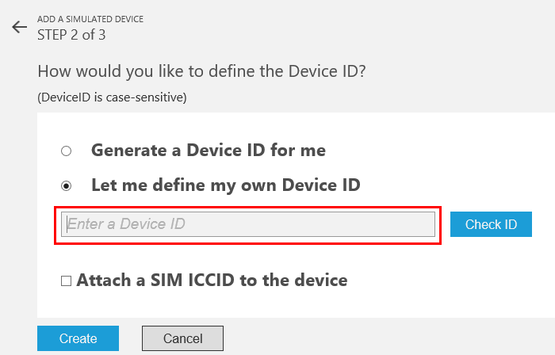

1. After creating new simulated device, it will be changed in device list from 4 device to 5 device.

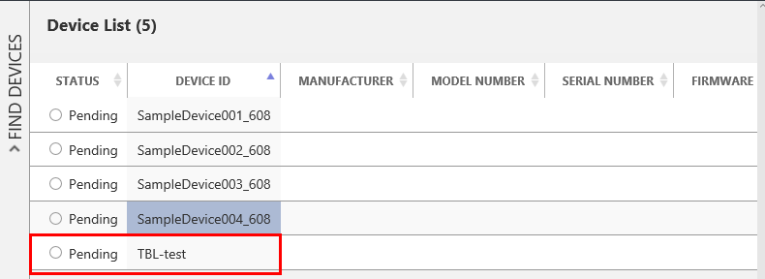

1. Review the other menu in left for Rules, Actions, and Advanced.

## Exercise 2: Create an IoT Hub in Azure.

The first task you have to perform is to creation of IoT Hub.

1. In a web browser, navigate to <http://portal.azure.com>. Sign into the portal using your subscription.
2. In the Hub menu (on the left edge), click New (indicated by a +), and in the “Internet of Things”, click Azure IoT Hub. Then use Azure Iot Hub section to create a new hub.

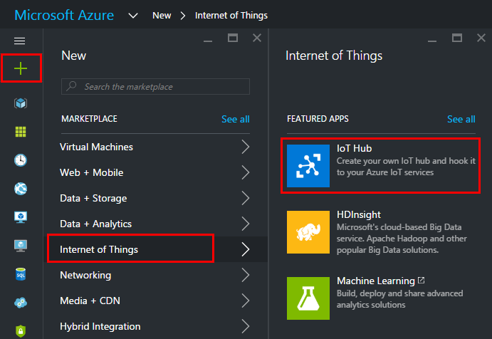

1. Create a new IoT hub with configuration value. The hub Name is unique name for IoT hub. If the Name is valid and available, a green check mark appears in the box.
2. Then, select a pricing and scale tier. You can change it regarding your requirement. For this lab, use the free F1 tier. IoT hub units are based on your total message count and the number of devices you want to connect. The Device-to-cloud partitions is the number of partitions for device-to-cloud messages. For this lab, use default values.
3. In Resource group, create a new group, or select an existing one. In Location, select the location to host your IoT hub.

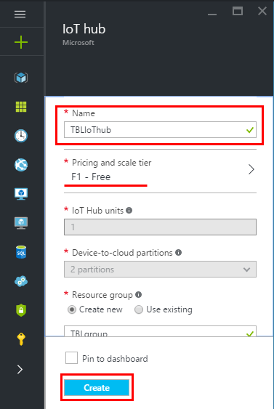

1. When you have chosen your IoT hub configuration values, click Create. It can take a few minutes for Azure to create your IoT hub. To check the status, you can monitor the progress in the Notifications panel.

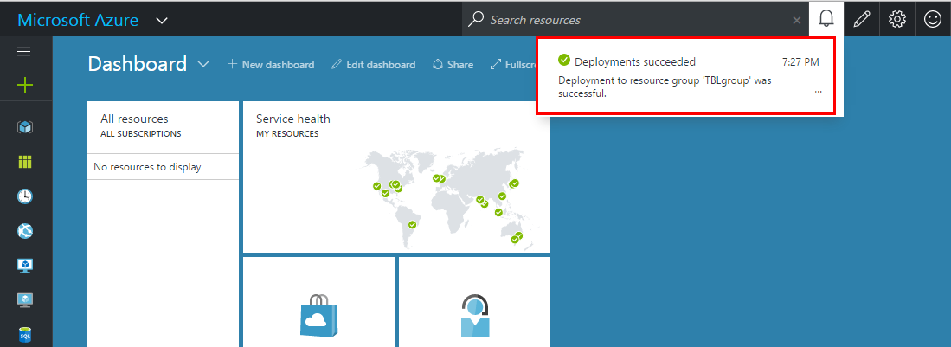

1. When the IoT hub has been created successfully, click the new section for your IoT in the portal to open the blade for the new IoT hub. Make a note of the Hostname, and tehen click the Keys icon.

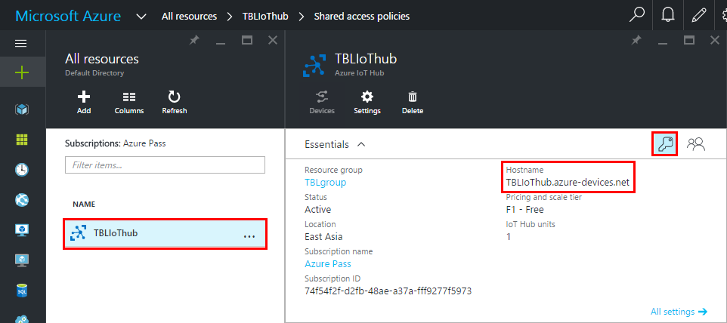

1. In the shared access policies blade, click the iothubowner policy, and then copy and make note of the connection string in the iothubowner blade.

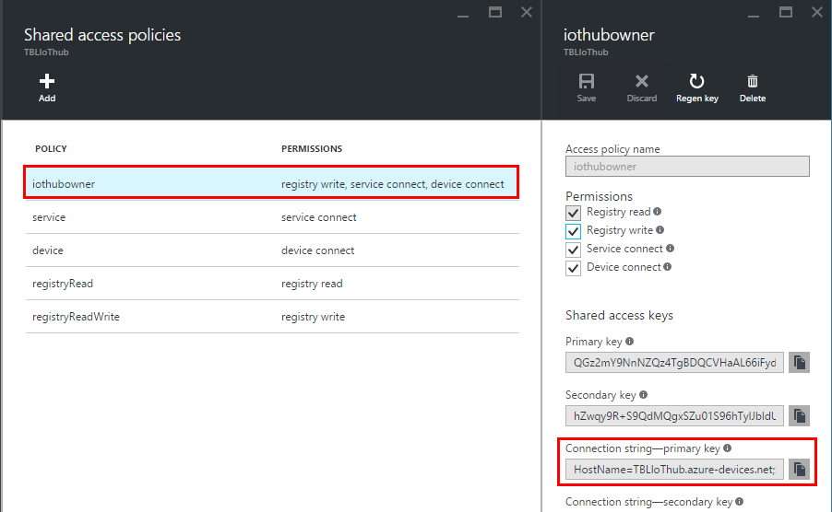

1. Click settins on the Iot Hub blade, then Messaging on the blade. On the message section, make a note of the Event Hub-compatible name and the Event Hub-compatible endpoint.

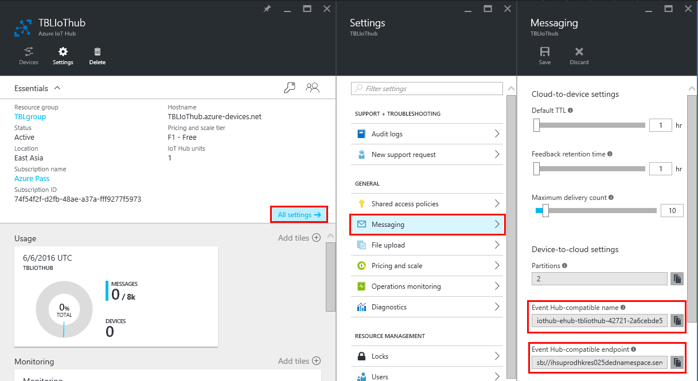

1. You have created your IoT hub, and you have the hostname, connection string, Event Hub-compatible name, and Event-Hub compatible endpoint value.

## Summary

In this hands-on lab, you learned how to:

* How to provision the remote monitoring preconfigured solution for IoT suite.
* How to use the Azure portal to create an IoT Hub.